Spotlight on a volunteer
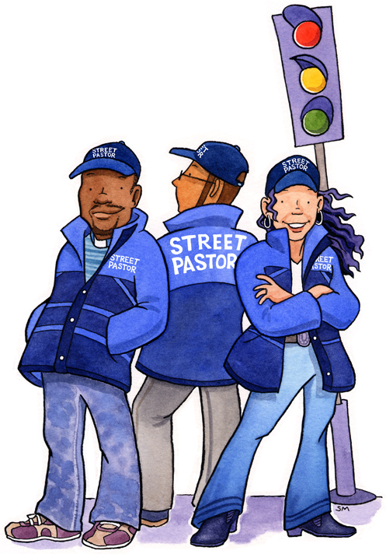
Please enter your answers to the questions below, then save
and return this form to communication@ascensiontrust.org.uk.
The total word count should be between 300 and 1000 words. Please do not identify local venues or locations in your Spotlight entry (published entries will not include the name of your Street Pastors area).

Photo
Along with the completed version of this document, please attach to your email a good-quality portrait/headshot photo.

First name (your surname will not be used)..................................................

Please tick: I am a prayer pastor...... rail pastor...... response pastor...... school & college pastor...... street pastor......

How old are you? ......................

Why did you choose to volunteer for this role?

How long have you been doing it?

Which parts of your role do you enjoy most and why?

What do you do when you are not street pastoring?

What has most surprised you about being a prayer/rail/response/school/street pastor?

What would you most like to see change in your town or city?

What do you do if you are finding an incident or an individual difficult?

Tell us one thing about you not related to street pastoring.

How has being a prayer/rail/response/school/street pastor changed you?

Thank you! Please save this form and return it to communication@ascensiontrust.org.uk. Entries will be published on www.streetpastors.org/spotlight-on-a-volunteer.

